The Arvigo Techniques of Maya Abdominal Therapy FAQs
Charlotte’s Healing Hands
Charlotte Westbrook
Austin, TX
512-422-2680

- What is The Arvigo Techniques of Maya Abdominal Therapy (ATMAT)?
- What is the fee for the sessions?
- How long is a session?
- Are there any conditions under which a massage should not be done?
- How does ATMAT work for women?
- What could cause a displaced uterus?
- What are the symptoms of a displaced uterus?
- How quickly should I expect a change?
- Is Uterine Massage recommended for all women?
- How is ATMAT helpful for men?
- Does ATMAT support fertility?
- I've had a Hysterectomy - how does ATMAT help?
- How does ATMAT help with Caesarian sections?
- How does ATMAT help with digestion?
- Will ATMAT help with digestion problems following abdominal surgery?
- What is "Self Care" and why does it help?

1. What is The Arvigo Techniques of Maya Abdominal Therapy (ATMAT)?
The Arvigo Techniques of Maya Abdominal Therapy is a non-invasive, external, massage technique. It guides internal abdominal organs into their proper position for optimum health and well-being. The technique works by relieving congestion and blockages to improve the flow of chi and fluids of the circulatory, lymphatic and nervous systems to prevent the progression of chronic disease symptoms. Maya massage improves organ function by releasing physical and emotional congestion from the abdomen. This massage is effective for both men and women.

2. What is the fee for the sessions?
The first session is $190. Subsequent sessions are $145. I do offer sliding scale for those in financial need.

3. How long is a session?
The first session lasts about 2 hours. The intake is extensive in order for the practitioner to get to know you and your individual needs. If time permits, and in order to receive the most out of the work, please complete and send in your intake form before your session date. The initial session also includes self-care massage instruction. You will take this knowledge and skill home with you in order to perform the work on yourself between sessions. The self-care massage is one of the most important aspects of this work. You will also receive an herbal tonic to enhance the massage work if we determine that that the tonic is appropriate for your particular needs. We suggest that, if possible, you schedule at least two sessions within a month’s time. Subsequent sessions require an hour to 1.5 hours.

4. What conditions are contraindicated for ATMAT?
- Five days prior to onset of menses.
- During menstruation.
- Within the first six weeks following a normal vaginal delivery or the first three months after a cesarean section
- After pelvic or abdominal surgery (until physician says it is safe to resume normal activities).
- If intrauterine device (IUD) is present.
- If cancer is present, or suspected anywhere in the pelvis.
- If infection is present anywhere in the pelvis.
- If pain or discomfort do not diminish beyond the sixth treatment.

5. How does it work for women?
This external massage gently lifts and guides the uterus into its optimal position in the lower pelvis. The uterus is held in position by over 10 ligaments. Ligaments, when stressed or strained cause the uterus to become mal-positioned. If the uterus is mal-positioned, women experience a multitude of symptoms.

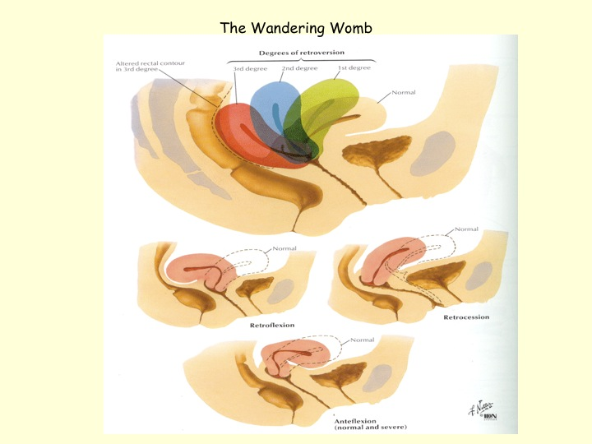

6. What could cause a displaced uterus?
- Injury to the sacrum or tailbone from a fall, car accidents, etc
- Pelvic ligaments that have weakened due to overstretching during pregnancy and birth
- High Impact exercise, running on cement surfaces, high impact aerobics, etc
- Lifting & carrying heavy objects before or during menstruation and too soon after childbirth
- Time and gravity
- Past surgeries
- Weak pelvic floor muscles
- Chronic muscle spasm around the low back and sacrum
- Emotional armoring from abuse at anytime in life

7. What are the symptoms of a displaced uterus?
- Painful or irregular periods; painful or irregular ovulation
- Dark or brown blood at the onset and at the end of menstruation
- Headache or migraine with period
- Varicose veins of the legs and/or tired, weak or numb legs
- Low backache; back pain with period
- More serious imbalances including: Endometriosis, Uterine Fibroids and Uterine Polyps
- PMS/ depression
- Frequent urination; bladder infections, incontinence
- Recurrent vaginal infections
- Chronic miscarriages
- Difficulty getting pregnant/Infertility
- Painful intercourse
- Chronic constipation
- Difficult menopause

8. How quickly should I expect a change?
Depending on the severity of the problem, it may take as little as one session and as long as many months for the uterine position to be corrected and for the ligaments to gain enough strength and elasticity for it to stay in place. 3 sessions are usually the minimum.
Women often report a rapid improvement in symptoms and sense of well being when self-care is performed regularly.

9. Is Uterine Massage recommended for all women?
Almost every woman, even those who have had hysterectomies can benefit greatly from Maya Uterine Massage through improved circulation, lymphatic drainage and a decrease in the formation of scar tissue.

Uterine massage is not performed:

- During menstrual bleeding
- Within the first 6 weeks following a normal vaginal delivery or the first 3 months after a c-section
- For a woman using an IUD for birth control
- If cancer is present or suspected anywhere in the pelvis, or the client is undergoing chemotherapy for this condition
- During the first trimester of pregnancy
- Hiatal Hernia - gentle touch only

10. How is this therapy helpful for men?
The massage is done the same way for men. The prostate is a glandular organ that rests behind the bladder it has no ligaments to speak of for support. The prostate gland can become congested resulting in early stages of Benign Prostatic Hypertrophy (BPH), impotence (depending on the cause), decrease sperm count, etc. By applying the massage to the abdomen it supports healthy organ function and relieves congestion.

11. Does ATMAT support fertility?
Approximately 30% of woman who have been unsuccessful in conceiving eventually conceive after a succession of ATMAT treatments. Treatments generally consist of massage, diet and lifestyle modifications, and herbal therapies to enhance fertility. After the uterus is realigned to its optimal position, the improved circulatory dynamics and homeostasis support and enhance fertility. ATMAT promotes and increases fertility when the male partner is also included in the process!

12. I've had a Hysterectomy - how does ATMAT help?
Women who have had hysterectomies benefit greatly from ATMAT as well. The technique improves circulation in and around the area of the scar and allows for proper flow of the lymph, which often becomes blocked after surgery, resulting in swelling, burning and deep aching pains in the pelvis. By using ATMAT techniques on a regular basis, scar tissue will be prevented from forming in the pelvis after surgery. Ligaments and other remaining organs are benefited from improving circulatory flow to the pelvis.

13. How does ATMAT help with Caesarian sections?
Caesarian births can be prevented by applying this simple, safe, and easy to learn massage technique. Our practitioners use ATMAT to help prevent the need for a C-Section. By strengthening and toning the uterus, ligaments and other pelvic organs, ATMAT helps to place and maintain the uterus in its optimal position for giving birth. Through this process, the well-being of the mother and baby improves as they prepare for labor and delivery. ATMAT midwife practitioners apply this technique during labor and delivery and report a decrease in laboring and easy delivery for mothers and babies. For women who have had a C-section, this technique is beneficial for breaking up scar tissue in the same way it works for women who have had hysterectomies.

14. How does ATMAT help with digestion?
Many anxieties and emotions stresses are stored in our body's tissues and organs. A very common place is in the organs of the digestive system. Those so called "butterflies in your stomach" can lead to constipation, indigestion, heartburn, and gastritis. In extreme cases, and these stresses may be precursors to more serious conditions including Irritable Bowel Syndrome (IBS), Gastro Esophageal Reflux (GERD), and Crohn's Disease. Over time stresses on the digestive system can cause the small intestine and colon to twist and kink resulting in blockages in the flow of peristalsis. The surrounding fascia creates adhesions that reorient the positions of organs, impede proper blood flow and enzyme secretions, and cause pain. The Arvigo Techniques of Maya Abdominal Therapy helps to break down facial adhesions and scar tissue and removes the blockages in the digestive tract. Often there is a dramatic improvement after just one session when combined with proper diet and self-care.

15. Will ATMAT help with digestion problems following abdominal surgery?
Scar tissue and facial adhesions can often cause problems with digestion after abdominal surgery. The Arvigo Techniques of Maya Abdominal Therapy helps to break down the scar tissue and adhesions from past or recent surgeries. Depending on individual conditions, a few sessions are required for reducing fascial restrictions. These sessions are combined with the application of castor oil packs, diet modification and self care massage. ATMAT is contraindicated immediately following abdominal surgery. Please allow 4-6 weeks before scheduling a massage, or consult with your physician to determine if you are ready for ATMAT.

16. What is "Self Care" and why does it help?
Clients are instructed in performing the abdominal massage for themselves. By doing self-care massage daily for 2 - 3 minutes per day, it provides the individual with the ability to improve their symptoms while working with their practitioner.

